Fatima Alobayah

202022243

CIS 201 - Fundamentals Web Design

Project name: movee

Description:

JavaScript quiz that gives you movie recommendations

When the user opens the website, they get a page with some questions they have to answer, then they can access movie/tv show recommendations page.

**Page layout:**

1. Layout of the landing page

welcome the user and ask them to take a quiz

[Grab your reader’s attention with a great quote from the document or use this space to emphasize a key point. To place this text box anywhere on the page, just drag it.]

Ok

1. Layout of the quiz (there will be multiple questions and at the end the user will submit) :

Question 1

1. Home page ( the blue squares are the movies) :

Home About me

Other design for the home page

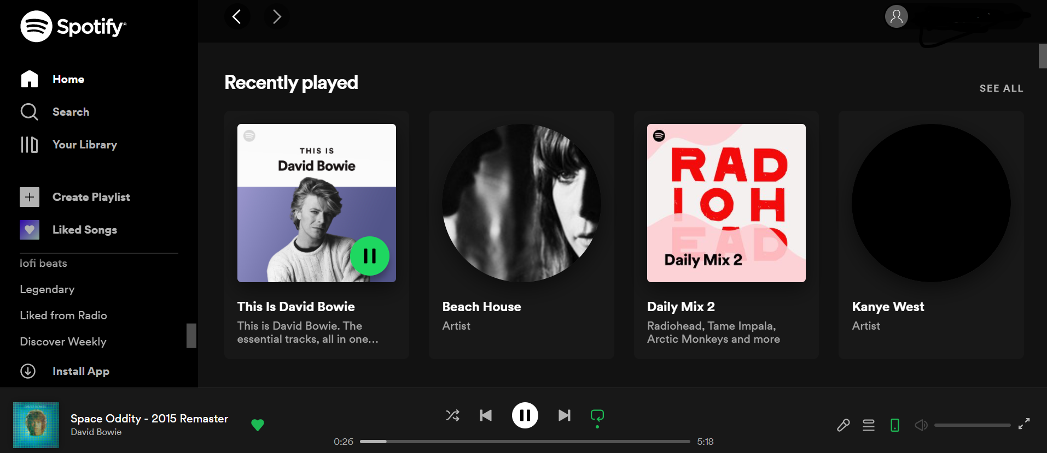

About me

Home

Figure page hierarchy

Index (landing page)

The quiz

Home page

About Me

Profile

The project page (logo )

1. The landing page is where the user is asked to take the quiz
2. The quiz is multiple choice
3. The home/project page has three links

* The project page, which is where the movies will be displayed
* About me
* The profile page displays the user’s profile

**Color scheme:**

The color scheme needs to be minimalistic, because the website will be filled with colorful movie/tv show posters. The background needs to be black or white, and for other things we need to choose one other color. The color scheme is inspired by Netflix, Spotify, Anghami, youtube…. websites with a lot of media tend to have this type of minimalistic color scheme consisting of two colors.

|  |  |  |
| --- | --- | --- |
| Color | Hexadecimal value | Used for |
|  | #181818 | Background |
|  | #212121 | Rows of movies |
|  | #AAAAAA | Lines |
|  | #FFFFFF | Text |
|  | #7ED957 | Logo |
|  | #99E8BC | Landing page background |
|  | #5A6978 | Landing page text, button |
|  | #699D80 | Quiz |

**Design:**

**The name of the website is “movee”**

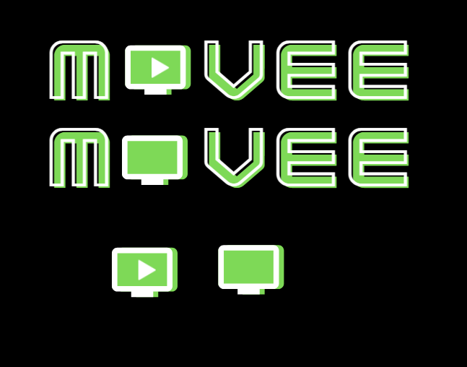

Figure 2 Logo

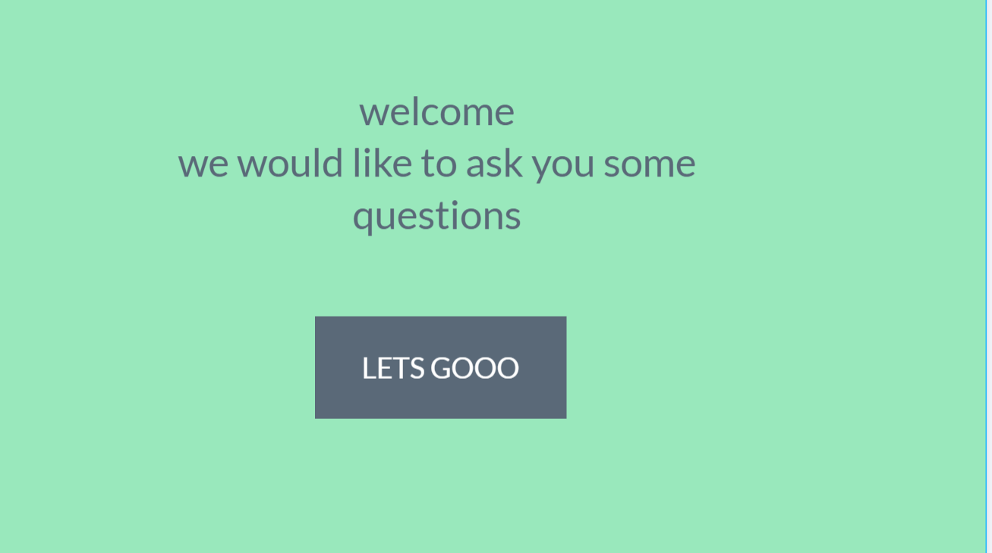

Figure 3 Landing page

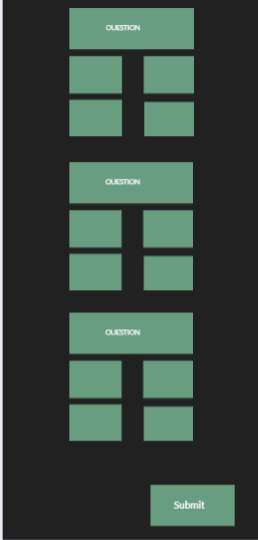

Figure 4 Quiz

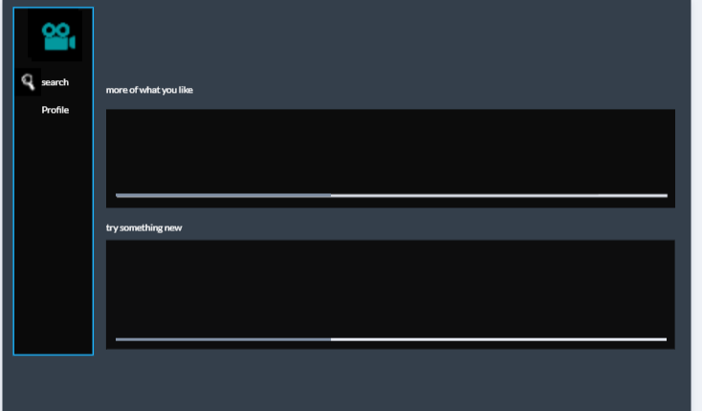

Figure 5 project page first draft

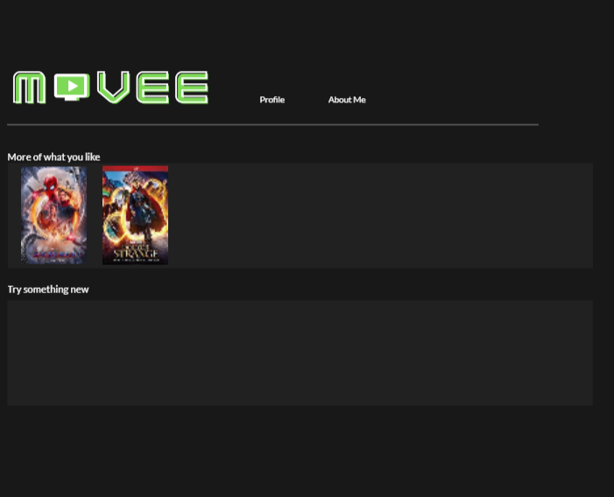

Figure 6 Project page second draft

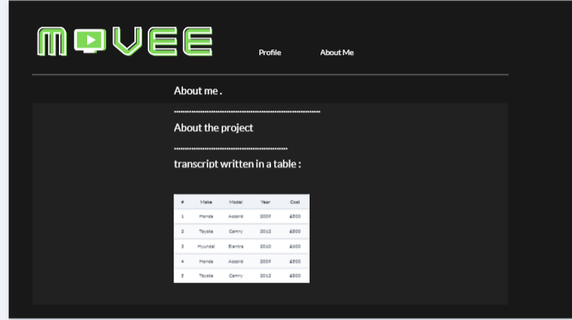

Figure About me page design

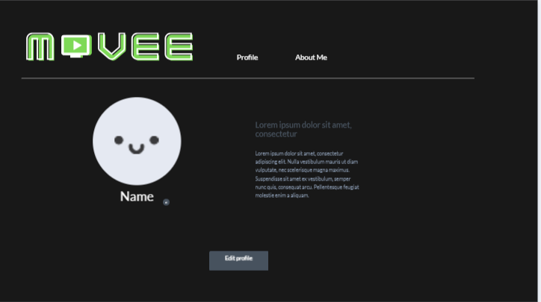

Figure profile page

**Content of the website:**

About me:

My name is Fatima Alobayah, I am currently second year software Engineering student. I’m a member of the google developers’ club. I am interested in data science and data mining.

Education:

Al Yamamah University Software Engineering

Transcript:

|  |  |  |  |
| --- | --- | --- | --- |
| Course code | Course Name | Description | Practical Work |
| CIS 202 | Data Structures | Object-oriented modeling techniques for analysis and design. Provides the tools and techniques needed to solve complex, real-world software engineering problems in an object-oriented manner, using the most effective elements of the Unified Process. The course covers the essential concepts and notation of the Unified Modeling Language (UML), the standard notation for object-oriented analysis and design. Team project. |  |
| CIS 103 | Programming Fundamentals I | In this course students will learn the basics of Java language syntax, elementary programming, selection and repetition, methods and arrays. They will gain experience by designing, writing, compiling and executing simple java programs. |  |
| CIS 104 | Programming fundamentals II | This course gives a thorough grounding in the basics of Object Oriented design and programming including Abstraction, Encapsulation, Polymorphism, Inheritance and Exception Handling. Emphasis will be placed on creating and manipulating objects and classes. They will also learn event-driven programming. Students will learn about these concepts in a Java development environment |  |
| CIS 201 | Fundamentals of Web Design | This course introduces basic concepts of the Internet and World-Wide Web. Students will learn how to create web pages with HTML, and use JavaScript for dynamic effects. Major topics include the roles and operation of web browsers and servers, including interacting with web applications through forms; and the separation of formatting and logical structure in HTML documents, stylesheets, and the basic principles of effective interface design for the web | https://github.com/fatima2838/CIS201.git |

About this project:

A website that recommends movies and TV shows to the user based on how they answer a quiz.

Place holders:

The dimensions of the posters will be 200* 300



**Updated description of html and js files:**

* **Html:** 
  + Landing page :

ask the user to take the quiz.

* + The quiz:

Ask the user questions about them, about their taste in music/games/TV, pop-culture questions, aim for fun questions that you think your target audience would enjoy. There are no right or wrong answers, the goal of the questions is to get the preferences of the user.

* + The Home page:

This is where all the main content is (the movie/TV posters).

* + The profile page:

The user information: picture, name, username, favorite genre.

Allow the user to edit and save their information.

* + About Movee:

Information about the employees, in this page there’s a link to my “about me page”

* **JavaScript:**
  + The quiz:

Change the color of the choices when clicked

* + Movieconstructor.js :
    - Create a movie constructor, use it to create all the movie objects
    - Create 4 arrays (playlist 1, 2 ,3, 4) and fill them with them with movie objects
    - Create another array named **Playlists**
    - Create random variable
    - Write an if statement that will fill **Playlists** with playlist#1, playlist#2 , playlist#3, playlist#4 in a different order BASED ON THE RANDOM NUMBER.
      * This means every time you load the page the recommendations will show up in a different order
    - Create an array of the playlistNames (Comedy, Drama, Action …..)
    - For loop to create div and img elements and display content.